Math Summer Projects 2022
All projects are optional. Turn in your project(s) to your math teacher on the first day of school for a reward! Work must be neat, and every aspect of the project must be complete. If you have any questions, please email Ms. Illiano at jilliano@bcps.org. Have fun with math!

#1. Surface Area
Supplies: 5 types of boxes (examples: cereal box, tissue box, popcorn box, cracker box, dryer sheet box), ruler
Find the surface area of each box. Use centimeters to measure to the nearest tenth. Use the formula below:
Surface Area = 2 times the length times the width, plus 2 times the length times the height, plus 2 times the width times the height
SA = $2\left(l∙w\right)+2\left(l∙h\right)+2(w∙h)$

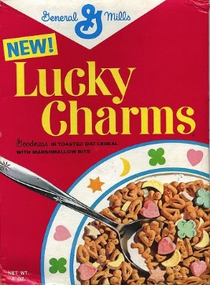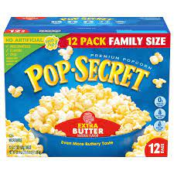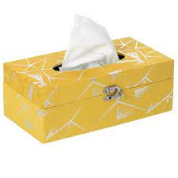
This Photo by Unknown Author is licensed under CC BY-NC-ND

#2. Egg Data
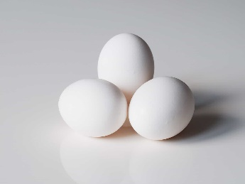
Ask 20 of your family or friends what is their favorite way to eat eggs. Tally and record the results in a frequency table.
Style of Eggs | Tally | Frequency
over easy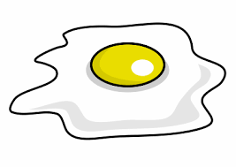
scrambled 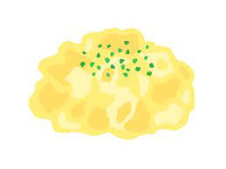
hard-boiled
omelet 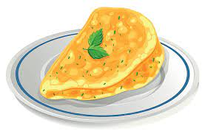
deviled 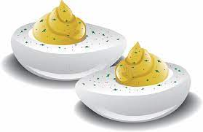

Now make a bar graph to display the data in your frequency table:
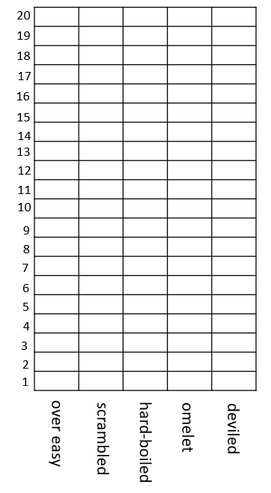
According to your data, which egg style is most likely to be ordered by your family and friends? ____________________
According to your data, which egg style is least likely to be ordered by your family and friends? ____________________
Are there any egg styles that are equally likely to be ordered by your family and friends? _____________________

#3. Mathe-magical Mystery Numbers
Use the clues provided to identify the mystery number in each crystal ball. Use the guess-and-check strategy to solve the riddles. Remember that a palindrome is a number that is the same forwards and backwards, such as 323 or 1,551. A prime number has exactly two factors, 1 and itself. The word “sum” means to add. The word “consecutive” means one after the other.
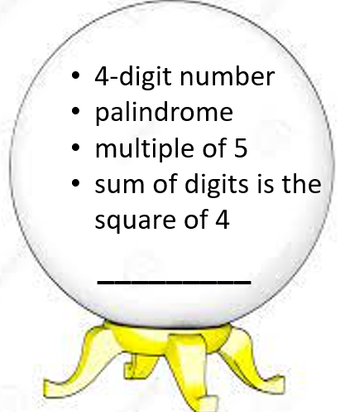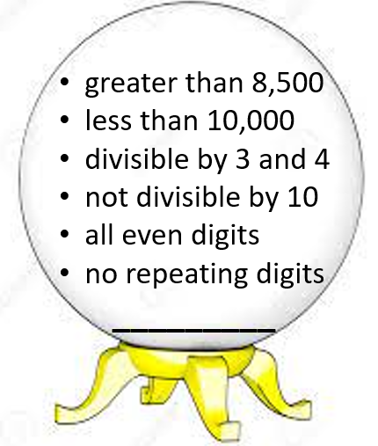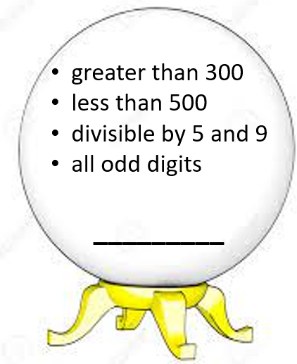

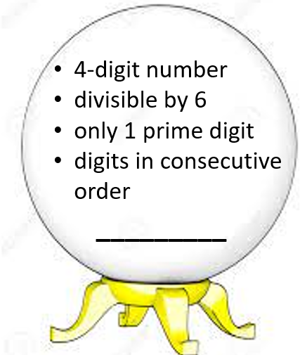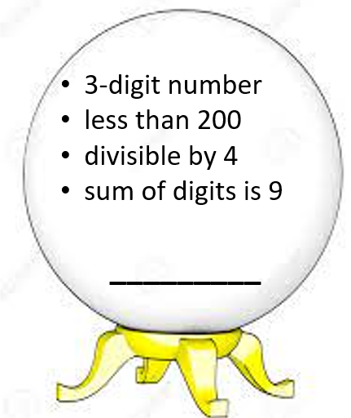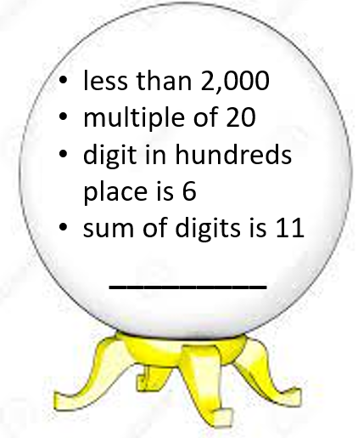
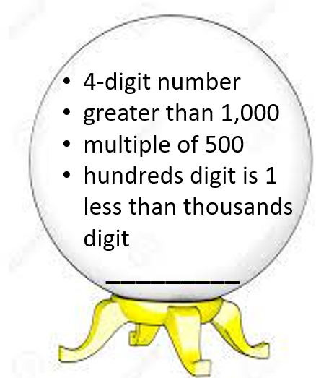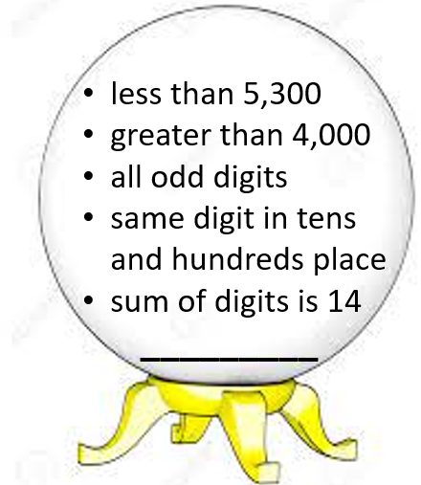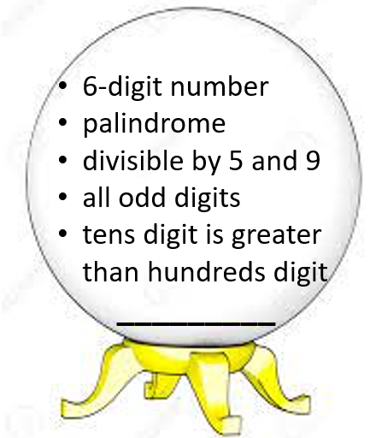
#4. One, Two, Three, Four
Make the numbers 0 - 20 using exactly one 1, one 2, one 3, and one 4. You can use any combination, including exponents and factorials (factorials are numbers written with an ! – for example 5! means 5 x 4 x 3 x 2 x 1 which equals 120). Don’t forget to use order of operations! (Example: (4 x 2 + 1) x 3 = 27)
1 | 2 | 3 | 4 | 5
6 | 7 | 8 | 9 | 10
11 | 12 | 13 | 14 | 15
16 | 17 | 18 | 19 | 20

#5. Magic Squares
Fill in the grids so that each column, row, and diagonal add up to the given sum.
2
 | 5 | 3
32
28
8
 | 10 | 6
12

The sum is 60.
The sum is 30.
The sum is 15.

Use deductive logic to complete the grid so that each row, each column, and each 3x3 box contains the numbers 1 through 9 in some order. There is only one solution.
 | 1 | 9 |  | 7 |  |  |  | 6
 |  | 2 |  |  |  | 7 | 8 | 5
 |  |  |  | 2 |  |  | 9
8 |  |  | 6 |  | 2 |  | 3
 | 2 |  | 4 |  | 7 |  | 5
 | 5 |  | 1 |  | 8 |  |  | 2
 | 3 |  |  | 6
1 | 8 | 5 |  |  |  | 6
9 |  |  |  | 8 |  | 2 | 4

#6. Shape Field Trip
Take a field trip around your home, neighborhood, grocery store, library, or community center. Look for each of the following shapes in the real world. Draw a picture or write a description of what you see.
Circle | Semicircle  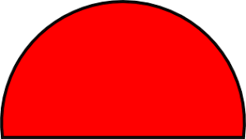 | Square
Rectangle | Triangle | Rhombus
Trapezoid | Paralleogram | Pentagon
Hexagon | Octagon | Oval

